GL Bajaj Institute of Technology & Management

**GAMING ERA**

**PROJECT REPORT**

**OF PROJECT**

**BACHELOR OF TECHNOLOGY**

COMPUTER SCIENCE & ENGINEERING

SUBMITTED BY

Vibhuti Narayan Patel (1901920100321)

Umang Dhama (1901920100303)

Varun Bhadauria (1901920100317)

Vaibhav Tiwari (1901920100308)

FEBRUAR 2021



SHIKHA SINGH

PROJECT COORDINATOR

**DEPARTMENT OF COMPUTER SCIENCE & ENGINEERING**

**GL Bajaj Institute of Technology & Management**

**(U.P.) – 201306**

**Abstract:**

Consider a situation where someone is new to the field of gaming and platforms, and being a novice in the field leaves a tremendous amount of scope for exploring, learning and discovery in the said field.

So, bearing that in mind, our website Gaming Era shall contain everything a novice or a pro gamer would require in order to get a fair understanding and unparalleled insight in the field of gaming, which shall further render assistance in monetizing their content on streaming platforms.

Our website shall include but not be limited to blogs on most popular gaming platforms, ways to gather traffic, data on games which get the most traffic, a community forum for gamers to connect, information on various esports events happening around the globe.

This website will also be used to spread awareness about games and the gaming community, and busting the myths associated with the same, segregating the fact from fiction and highlighting and bringing to light the tremendous scope in the field of gaming.

**Motivation:**

At present the websites on the internet usually capture the details/specification of games, blogs about gaming, and streaming platforms. But there exists a lacuna of one stop shop which would contain all the necessary information qua gaming and is accessible easily, this is where Gaming Era steps in to bridge the gap prevailing in the market.

It is a fact that in the course of previous year the gaming market generated somewhere around US$ 138.7 Billion in revenue[1]. The prediction from Newzoo a reputed and reliable source is that in year 2019, it shall increase by about 9.6% to generate up to US$ 152.1 Billion in revenue. The video game industry grew at the rate of about 10% in 2018, it is thus established that during the current pandemic scenario the gaming industry is set to grow at unprecedented level.

Leading experts in the market believe that in the year 2020 global gaming market will be able to generate revenues of up to US$ 159.3 Billion, a healthy year-on-year growth of +9.3%, which coupled with the pandemic and people being locked up in their homes, it shall be safe to conclude that the actual growth may very well surpass the projections.

Despite the developments, the gaming industry is still in its nascent stage and this could be an opportune time for investment in the said field which is set to offer unprecedented returns in the times to come.

Bearing the contentions and the data cited hereinabove, our main objective is to provide people with a platform that is one stop shop for their gaming needs and connect with the community at a subliminal level across the globe. We further emphasize on formation of a community that is self sustaining and organic and has something to offer to anyone and everyone who is associated with it.

**Literature review:**

1. What is esports? A look at an explosive billion-dollar industry[2] by [AJ Willingham](https://edition.cnn.com/profiles/aj-willingham-profile), CNN:

The following is the inspiration for the website -

In reality, the world of competitive video gaming is a fast-growing international phenomenon with millions of fans and billions of dollars up for grabs. Streaming services and live events have turned casual gamers into serious stars who can sometimes rake in seven-figure earnings and massive brand endorsements.

Esports describes the world of competitive, organized video gaming. Competitors from different leagues or teams face off in the same games that are popular with at-home gamers. According to a report from Newzoo, a market analytics company, 380 million people worldwide will watch esports this year, including 165 million esports enthusiasts.

The games market will continue to grow in the following years, **exceeding $200 billion at the end of 2023**. By then, we forecast the games market to grow with a +8.3% CAGR to US$ 200.8 billion. That's a lucrative market, not only for the players, but for brands and video game producers as well.

Players also earn money from sponsorships, endorsements and league salaries. To that end, Newzoo reports brands will invest $694 million in eSports ventures this year alone.

Esports has the potential to be a career option for the individuals who are passionate about gaming. It has tremendous possibilities for different brands and companies for expanding their outreach. It has given opportunity to people from all walks of life to connect and display their skills, including disabled individuals and people who are not into other forms of sports. It helps to fasten eye - hand coordination and better reflexes. It is great recreational and fun activity.

The platforms are crowded and it may take a long time to get established enough to make a living out of it. Esports is still a growing industry and many companies may be hesitant in making substantial investments. It is time consuming and requires persistence to be successful in this field and the success ratio is small compared to other career options. It also has degrading health effects over long time. It promotes addiction and high exposure to screen and may lead to procrastination and disassociation from reality

**Problem formulation/Objectives:**

* Information about various aspects of Gaming
* Sign up and login functionality
* Blogs - 1. Guides for people new to gaming

2. Guides for various streaming platforms

3. Tech specifications and reviews about games.

4. Guides for monetizing content and many more

* Community for gamers to connect
* Forums for discussing an issue
* Writing reviews about games
* Alerts such as news, new releases, and events

**Methodology/ Planning of work:**

Week 1: Discussion about website content and basic structure

Week 2: Designing the user interface and features

Week 3: Front End coding of the website

Week 4: Integrating all third party features

Week 5: Getting the Back End coded and working

Week 7: Optimising all features and content in the website

Week 8: Testing the website and analysing user interaction

Week 9: Removing all the bugs and finalizing the website

Week 10: Submitting the project

**Facilities required for proposed work:**

1. Front-end: For the Front-end of the website, we will be using:

HTML - to define structure of web pages

CSS (Cascading Style Sheet) - for stylizing the structure

JS (JavaScript) - for the user to interact with the webpage

2. Back-end: for Back-end, we will be using:

PHP – language for functionality of the webpage

MySQL – open-source relational database management system

**Website UI:**

Navigation Bar:-



ul {

list-style-type: none;

margin: 0;

padding: 0;

overflow: hidden;

background-color: #002A32;

position: -webkit-sticky; /* Safari */

position: sticky;

top: 0;

}

li {

float: left;

}

li a {

display: block;

color: white;

text-align: center;

padding: 14px 16px;

text-decoration: none;

}

li a:hover {

background-color: #FF5A5F;

}

.active {

background-color: #F1A208;

}

<ul>

<li><svg xmlns="http://www.w3.org/2000/svg" fill="none" stroke="currentColor" stroke-linecap="round" stroke-linejoin="round" stroke-width="2" class="w-10 h-10 text-white p-2 bg-indigo-500 rounded-full" viewBox="0 0 24 24">

<path d="M12 2L2 7l10 5 10-5-10-5zM2 17l10 5 10-5M2 12l10 5 10-5"></path>

</svg>

</li>

<li><a class="active" href="GR.html">Home</a></li>

<li><a href="PC-Games.html">PC Games</a></li>

<li><a href="Android-games.html">Mobile Games</a></li>

<li><a href="https://discord.gg/EHVEs9Ax9E">Community</a></li>

<li><a href="esports.html">E-Sports</a></li>

<li><a href="index.html">Top Games</a></li>

<li><a href="News1.htm">News</a></li>

<li style="float:right"><a href="http://localhost/registration/login.php">Log In</a></li>

<li style="float:right"><a href="http://localhost/registration/register.php">Sign Up</a></li>

</ul>

Slide Show:-

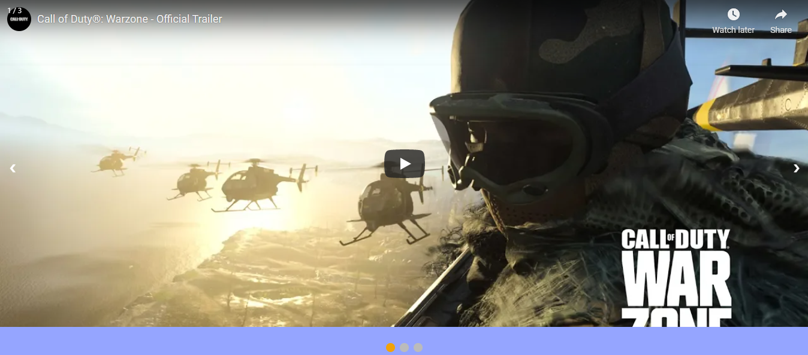

{box-sizing: border-box}

body {font-family: Verdana, sans-serif; margin:0}

.mySlides {display: none}

.slideshow-container {

max-width: 100%;

position: relative;

margin: auto;

}

.prev, .next {

cursor: pointer;

position: absolute;

top: 50%;

width: auto;

padding: 16px;

margin-top: -22px;

color: white;

font-weight: bold;

font-size: 18px;

transition: 3s ease;

border-radius: 0 3px 3px 0;

user-select: none;

}

.next {

right: 0;

border-radius: 3px 0 0 3px;

}

.prev:hover, .next:hover {

background-color: rgba(0,0,0,0.8);

}

.text {

color: #f2f2f2;

font-size: 15px;

padding: 8px 12px;

position: absolute;

bottom: 8px;

width: 100%;

text-align: center;

}

.numbertext {

color: #f2f2f2;

font-size: 12px;

padding: 8px 12px;

position: absolute;

top: 0;

}

.dot {

cursor: pointer;

height: 15px;

width: 15px;

margin: 0 2px;

background-color: #bbb;

border-radius: 50%;

display: inline-block;

transition: background-color 3s ease;

}

.active, .dot:hover {

background-color: #717171;

}

@media only screen and (max-width: 300px) {

.prev, .next,.text {font-size: 11px}

}

<div class="slideshow-container">

<div class="mySlides">

<div class="numbertext">1 / 3</div>

<iframe width="100%" height="90%" src="https://www.youtube.com/embed/0E44DClsX5Q?autoplay=0&mute=1">

</iframe>

</div>

<div class="mySlides">

<div class="numbertext">2 / 3</div>

<iframe width="100%" height="90%" src="https://www.youtube.com/embed/D0wpgyoj7uM?autoplay=0&mute=1">

</iframe>

</div>

<div class="mySlides">

<div class="numbertext">3 / 3</div>

<iframe width="100%" height="90%" src="https://www.youtube.com/embed/UMJb_mkqynU?autoplay=0&mute=1">

</iframe>

</div>

<a class="prev" onclick="plusSlides(-1)">&#10094;</a>

<a class="next" onclick="plusSlides(1)">&#10095;</a>

</div>

<br>

<div style="text-align:center">

<span class="dot" onclick="currentSlide(1)"></span>

<span class="dot" onclick="currentSlide(2)"></span>

<span class="dot" onclick="currentSlide(3)"></span>

</div>

<script>

var slideIndex = 1;

showSlides(slideIndex);

function plusSlides(n) {

showSlides(slideIndex += n);

}

function currentSlide(n) {

showSlides(slideIndex = n);

}

function showSlides(n) {

var i;

var slides = document.getElementsByClassName("mySlides");

var dots = document.getElementsByClassName("dot");

if (n > slides.length) {slideIndex = 1}

if (n < 1) {slideIndex = slides.length}

for (i = 0; i < slides.length; i++) {

slides[i].style.display = "none";

}

for (i = 0; i < dots.length; i++) {

dots[i].className = dots[i].className.replace(" active", "");

}

slides[slideIndex-1].style.display = "block";

dots[slideIndex-1].className += " active";

}

</script>

News (NEW YORK TIMES API):-

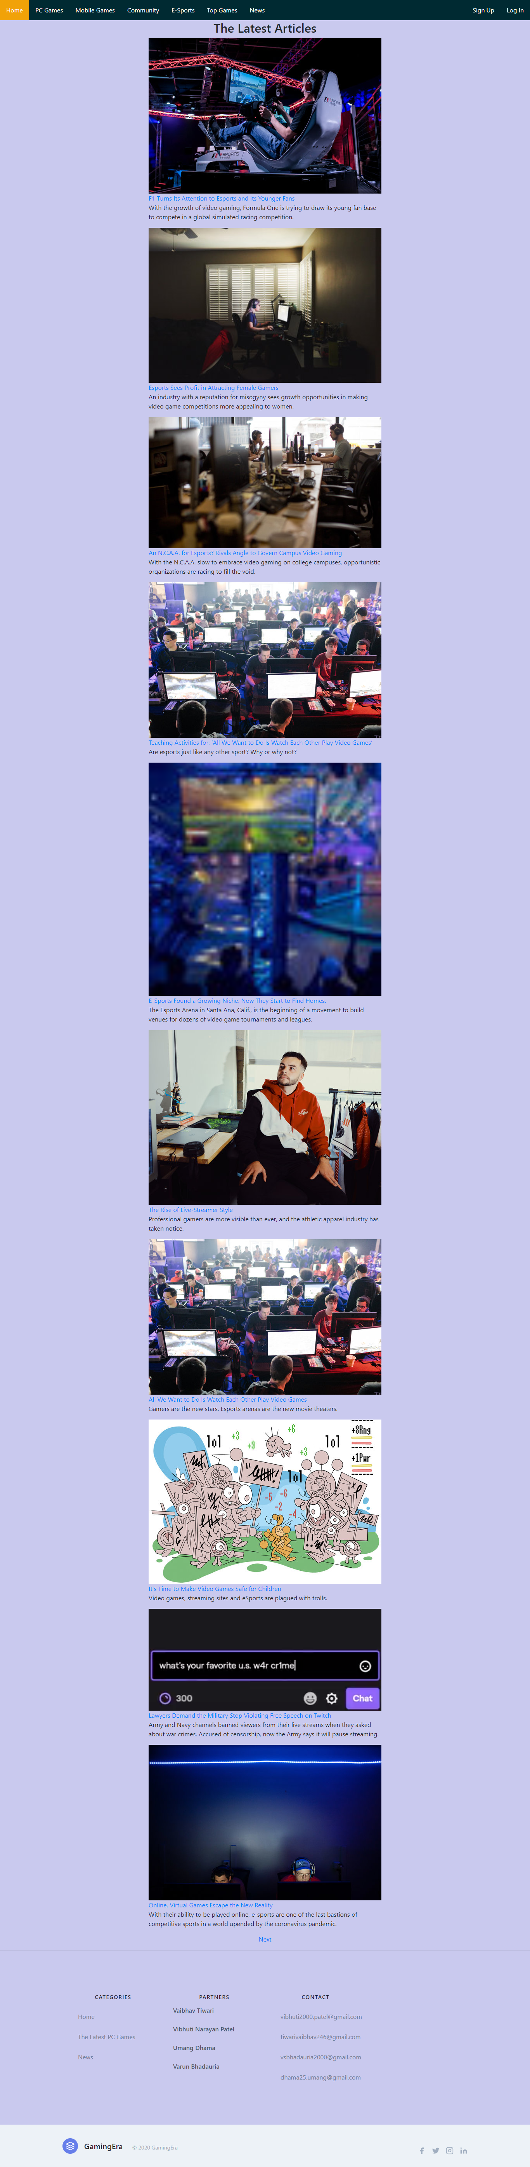

JS:-

let url="https://api.nytimes.com/svc/search/v2/articlesearch.json?q=esports&api-key=MGTTHAFaDPJut8YlIJfDcP4X4LBIStGV";

let headlines = document.getElementById("headlines");

fetch(url)

.then(response => response.json())

.then(data => {

console.log(data);

data.response.docs.map(article =>{

console.log(article.headline.main);

let a = document.createElement("a");

a.setAttribute('href', article.web_url);

a.innerHTML = article.headline.main;

let p = document.createElement("p");

p.innerHTML = article.abstract;

let img = document.createElement("img");

su = "https://static01.nyt.com/";

du = article.multimedia[0].url;

ur = su + du;

img.setAttribute('src', ur);

headlines.appendChild(img);

headlines.appendChild(a);

headlines.appendChild(p);

})

})

HTML:-

<body style="background-color:#C9C9EE;">

<div class="content">

<center><h2>The Latest Articles</h2></center>

<div class="clearfix" id="headlines"></div>

<script src="News1.js"></script>

<center><a href="News2.htm">Next</a></center>

</div>

</body>

Top Games (RAWG API):-

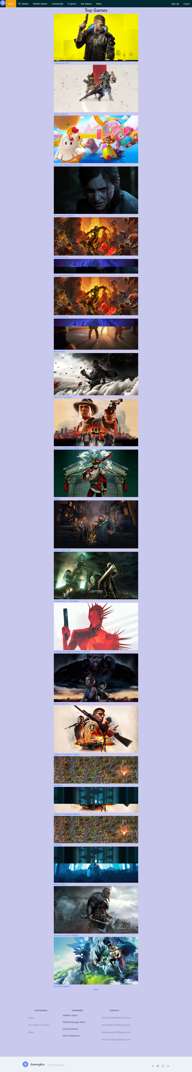

JS:-

let url = "https://api.rawg.io/api/games?dates=2020-01-01%2C2020-12-31&ordering=-added&page=1";

let games = document.getElementById("games");

fetch(url)

.then(response => response.json())

.then(data => {

console.log(data);

data.results.map(article =>{

console.log(article.slug);

su = "https://rawg.io/games/";

du = article.slug;

ur = su + du;

let a = document.createElement("a");

a.setAttribute('href', ur);

a.innerHTML = article.name;

let img = document.createElement("img");

img.setAttribute('src', article.background_image);

games.appendChild(img);

games.appendChild(a);

})

})

HTML:-

<body style="background-color:#C9C9EE;">

<div class="content">

<center><h2>Top Games</h2></center>

<div id="games"></div>

<script src="script1.js"></script>

<center><a href="index1.html" align="right">Next</a></center>

</div>

</body>

PC Games:-

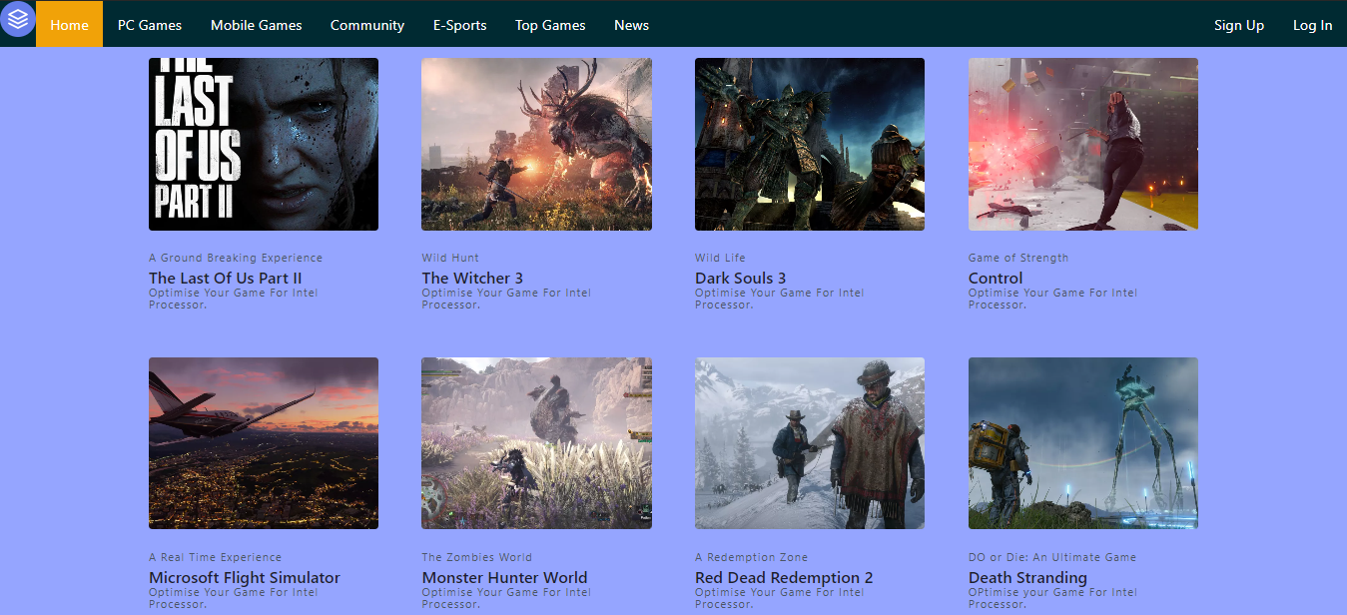

<section class="text-gray-700 body-font">

<div class="container px-5 py-24 mx-auto">

<div class="flex flex-wrap -m-4">

<div class="lg:w-1/4 md:w-1/2 p-4 w-full">

<a class="block relative h-48 rounded overflow-hidden">

<img alt="ecommerce" class="object-cover object-center w-full h-full block" src="https://s3.gaming-cdn.com/images/products/6215/orig/the-last-of-us-part-ii-cover.jpg">

</a>

<div class="mt-4">

<h3 class="text-gray-1100 text-xs tracking-widest title-font mb-1">A Ground Breaking Experience</h3>

<a herf="https://www.playstation.com/en-in/games/the-last-of-us-part-ii/"><h2 class="text-gray-900 title-font text-lg font-medium">The Last Of Us Part II</h2></a>

<a href="https://gameplay.intel.com/"><h3 class="text-gray-1100 text-xs tracking-widest title-font mb-1">Optimise Your Game For Intel Processor.</h3></a>

<p class="mt-1"></p>

</div>

</div>

<div class="lg:w-1/4 md:w-1/2 p-4 w-full">

<a class="block relative h-48 rounded overflow-hidden">

<img alt="ecommerce" class="object-cover object-center w-full h-full block" src="https://cdn.mos.cms.futurecdn.net/SX3hwkCKgRwTHfjy7NBwoH-970-80.jpg.webp

">

</a>

<div class="mt-4">

<h3 class="text-gray-1100 text-xs tracking-widest title-font mb-1">Wild Hunt</h3>

<a href="#"><h2 href="#" class="text-gray-900 title-font text-lg font-medium">The Witcher 3</h2></a>

<a href="https://gameplay.intel.com/"><h3 class="text-gray-1100 text-xs tracking-widest title-font mb-1">Optimise Your Game For Intel Processor.</h3></a>

<p class="mt-1"></p>

</div>

</div>

<div class="lg:w-1/4 md:w-1/2 p-4 w-full">

<a class="block relative h-48 rounded overflow-hidden">

<img alt="ecommerce" class="object-cover object-center w-full h-full block" src="https://cdn.mos.cms.futurecdn.net/C5x4BxuiKCHwKix82McUqi-970-80.jpg.webp">

</a>

<div class="mt-4">

<h3 class="text-gray-1100 text-xs tracking-widest title-font mb-1">Wild Life</h3>

<a href="#"><h2 href="#" class="text-gray-900 title-font text-lg font-medium">Dark Souls 3</h2></a>

<a href="https://gameplay.intel.com/"><h3 class="text-gray-1100 text-xs tracking-widest title-font mb-1">Optimise Your Game For Intel Processor.</h3></a>

<p class="mt-1"></p>

</div>

</div>

<div class="lg:w-1/4 md:w-1/2 p-4 w-full">

<a class="block relative h-48 rounded overflow-hidden">

<img alt="ecommerce" class="object-cover object-center w-full h-full block" src="https://cdn.mos.cms.futurecdn.net/sqioeGCsW938qgpaV7sNdL-970-80.jpg.webp">

</a>

<div class="mt-4">

<h3 class="text-gray-1100 text-xs tracking-widest title-font mb-1">Game of Strength</h3>

<a href="#"><h2 class="text-gray-900 title-font text-lg font-medium">Control</h2></a>

<a href="https://gameplay.intel.com/"><h3 class="text-gray-1100 text-xs tracking-widest title-font mb-1">Optimise Your Game For Intel Processor.</h3></a>

<p class="mt-1"></p>

</div>

</div>

<div class="lg:w-1/4 md:w-1/2 p-4 w-full">

<a class="block relative h-48 rounded overflow-hidden">

<img alt="ecommerce" class="object-cover object-center w-full h-full block" src="https://cdn.mos.cms.futurecdn.net/tpen2EQ8sKLKsev7Mkxn6M-970-80.jpg.webp

">

</a>

<div class="mt-4">

<h3 class="text-gray-1100 text-xs tracking-widest title-font mb-1">A Real Time Experience</h3>

<a href="#"><h2 class="text-gray-900 title-font text-lg font-medium"> Microsoft Flight Simulator</h2></a>

<a href="https://gameplay.intel.com/"><h3 class="text-gray-1100 text-xs tracking-widest title-font mb-1">Optimise Your Game For Intel Processor.</h3></a>

<p class="mt-1"></p>

</div>

</div>

<div class="lg:w-1/4 md:w-1/2 p-4 w-full">

<a class="block relative h-48 rounded overflow-hidden">

<img alt="ecommerce" class="object-cover object-center w-full h-full block" src="https://cdn.mos.cms.futurecdn.net/iFt92pU9DYWoRhiYErx57X-970-80.jpg.webp">

</a>

<div class="mt-4">

<h3 class="text-gray-1100 text-xs tracking-widest title-font mb-1"> The Zombies World</h3>

<a href ="#"><h2 class="text-gray-900 title-font text-lg font-medium">Monster Hunter World</h2></a>

<a href="https://gameplay.intel.com/"><h3 class="text-gray-1100 text-xs tracking-widest title-font mb-1">Optimise Your Game For Intel Processor.</h3></a>

<p class="mt-1"></p>

</div>

</div>

<div class="lg:w-1/4 md:w-1/2 p-4 w-full">

<a class="block relative h-48 rounded overflow-hidden">

<img alt="ecommerce" class="object-cover object-center w-full h-full block" src="https://cdn.mos.cms.futurecdn.net/H5VxFsNybtHVBh9qhtuG66-970-80.jpg.webp

">

</a>

<div class="mt-4">

<h3 class="text-gray-1100 text-xs tracking-widest title-font mb-1">A Redemption Zone </h3>

<a href="#"><h2 class="text-gray-900 title-font text-lg font-medium">Red Dead Redemption 2</h2></a>

<a href="https://gameplay.intel.com/"><h3 class="text-gray-1100 text-xs tracking-widest title-font mb-1">Optimise Your Game For Intel Processor.</h3></a>

<p class="mt-1"></p>

</div>

</div>

<div class="lg:w-1/4 md:w-1/2 p-4 w-full">

<a class="block relative h-48 rounded overflow-hidden">

<img alt="ecommerce" class="object-cover object-center w-full h-full block" src=" https://cdn.mos.cms.futurecdn.net/tXyyy29xoCJfRL3XCGXpdZ-970-80.jpg.webp">

</a>

<div class="mt-4">

<h3 class="text-gray-1100 text-xs tracking-widest title-font mb-1">DO or Die: An Ultimate Game</h3>

<a href="#"><h2 class="text-gray-900 title-font text-lg font-medium"> Death Stranding</h2></a>

<a href="https://gameplay.intel.com/"><h3 class="text-gray-1100 text-xs tracking-widest title-font mb-1">OPtimise your Game For Intel Processor.</h3></a>

<p class="mt-1"></p>

</div>

</div>

</div>

</div>

</section>

Android Games:-

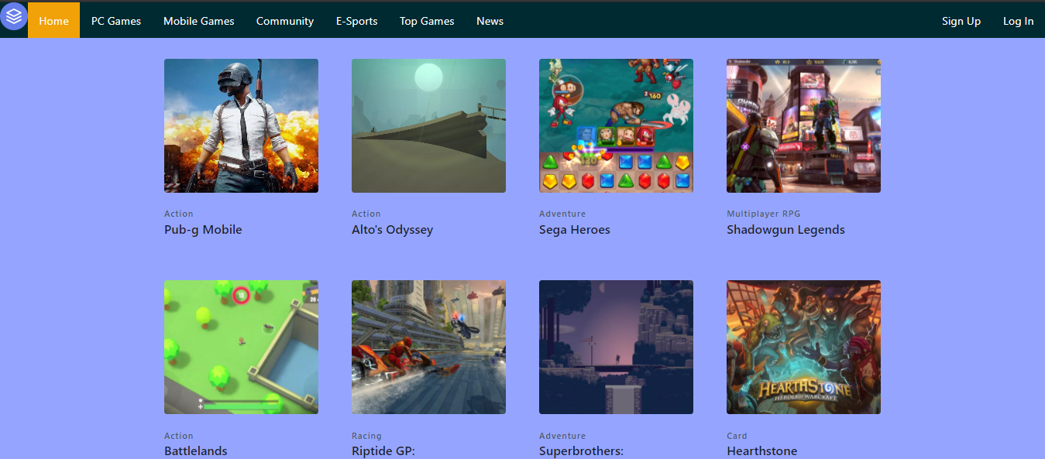

<section class="text-gray-700 body-font">

<div class="container px-5 py-24 mx-auto">

<div class="flex flex-wrap -m-4">

<div class="lg:w-1/4 md:w-1/2 p-4 w-full">

<a class="block relative h-48 rounded overflow-hidden">

<img alt="ecommerce" class="object-cover object-center w-full h-full block" src="https://images.moneycontrol.com/static-mcnews/2019/05/PUBG-Inlay-770x433.jpg?impolicy=website&width=770&height=431">

</a>

<div class="mt-4">

<h3 class="text-gray-1100 text-xs tracking-widest title-font mb-1">Action</h3>

<a href="https://play.google.com/store/apps/details?id=com.tencent.iglite&hl=en_IN&gl=US"><h2 class="text-gray-900 title-font text-lg font-medium">Pub-g Mobile</h2></a>

<a href="#"><p class="mt-1"></p></a>

</div>

</div>

<div class="lg:w-1/4 md:w-1/2 p-4 w-full">

<a class="block relative h-48 rounded overflow-hidden">

<img alt="ecommerce" class="object-cover object-center w-full h-full block" src="https://cnet3.cbsistatic.com/img/eU8toLYkAxGKaYi6E4Hgyl1VMOA=/980x0/2018/02/21/54eaecf2-be35-4f9c-a44f-47d09ea49a91/img-1590.jpg">

</a>

<div class="mt-4">

<h3 class="text-gray-1100 text-xs tracking-widest title-font mb-1">Action</h3>

<a href="https://play.google.com/store/apps/details?id=com.noodlecake.altosodyssey&hl=en_IN&gl=US"><h2 class="text-gray-900 title-font text-lg font-medium">Alto's Odyssey</h2></a>

<a href="#"><p class="mt-1"></p></a>

</div>

</div>

<div class="lg:w-1/4 md:w-1/2 p-4 w-full">

<a class="block relative h-48 rounded overflow-hidden">

<img alt="ecommerce" class="object-cover object-center w-full h-full block" src="https://cnet2.cbsistatic.com/img/QB2ncnp9u18mY5uYc0mP3mDni_k=/980x0/2018/12/03/212e2edc-04b7-4c0a-81e0-eb1a0a2aa383/sega-heroes.png">

</a>

<div class="mt-4">

<h3 class="text-gray-1100 text-xs tracking-widest title-font mb-1">Adventure</h3>

<a href="https://sega-heroes.en.uptodown.com/android"><h2 class="text-gray-900 title-font text-lg font-medium">Sega Heroes</h2></a>

<a href="#"><p class="mt-1"></p></a>

</div>

</div>

<div class="lg:w-1/4 md:w-1/2 p-4 w-full">

<a class="block relative h-48 rounded overflow-hidden">

<img alt="ecommerce" class="object-cover object-center w-full h-full block" src="https://cnet3.cbsistatic.com/img/YRct1of6M8HYbwL80fCzG2XstO0=/980x0/2018/08/02/1b8b17a5-efa8-41ab-8219-b24a5ec49a32/shadowgunlegends.jpg">

</a>

<div class="mt-4">

<h3 class="text-gray-1100 text-xs tracking-widest title-font mb-1">Multiplayer RPG</h3>

<a href="https://apps.apple.com/us/app/shadowgun-legends-online-fps/id1091251242"><h2 class="text-gray-900 title-font text-lg font-medium">Shadowgun Legends</h2></a>

<a href="#"><p class="mt-1"></p></a>

</div>

</div>

<div class="lg:w-1/4 md:w-1/2 p-4 w-full">

<a class="block relative h-48 rounded overflow-hidden">

<img alt="ecommerce" class="object-cover object-center w-full h-full block" src="https://cnet2.cbsistatic.com/img/x5AYkjFSmn12Q4_jRxaeejS7KAw=/980x0/2018/08/02/7fb56b50-7cfc-4f8c-97dc-7e69b13a330a/battlelands.jpg">

</a>

<div class="mt-4">

<h3 class="text-gray-1100 text-xs tracking-widest title-font mb-1">Action</h3>

<a href="https://play.google.com/store/apps/details?id=com.futureplay.battleground&hl=en_IN&gl=US"><h2 class="text-gray-900 title-font text-lg font-medium">Battlelands</h2></a>

<a href="#"><p class="mt-1"></p></a>

</div>

</div>

<div class="lg:w-1/4 md:w-1/2 p-4 w-full">

<a class="block relative h-48 rounded overflow-hidden">

<img alt="ecommerce" class="object-cover object-center w-full h-full block" src="https://cnet1.cbsistatic.com/img/3naf6CqHieYvJMV3xgQk4UGwKfg=/980x0/2017/03/24/2dfaba9a-3e96-4ee6-bcb8-46a8a84a596d/ios-27.jpg">

</a>

<div class="mt-4">

<h3 class="text-gray-1100 text-xs tracking-widest title-font mb-1">Racing</h3>

<a href="https://play.google.com/store/apps/details?id=com.vectorunit.silver.googleplay&hl=en_IN&gl=US"><h2 class="text-gray-900 title-font text-lg font-medium">Riptide GP:</h2></a>

<a href="#"><p class="mt-1"></p></a>

</div>

</div>

<div class="lg:w-1/4 md:w-1/2 p-4 w-full">

<a class="block relative h-48 rounded overflow-hidden">

<img alt="ecommerce" class="object-cover object-center w-full h-full block" src="https://cnet1.cbsistatic.com/img/7_dNV-NWhHUnfuA9WLYRRNbbmjg=/980x0/2017/03/24/4545874c-1e3c-4c11-b9fb-b8626c928e41/ios-28.jpg">

</a>

<div class="mt-4">

<h3 class="text-gray-1100 text-xs tracking-widest title-font mb-1">Adventure</h3>

<a href="https://play.google.com/store/apps/details?id=com.capybaragames.sworcery&hl=en_IN&gl=US"><h2 class="text-gray-900 title-font text-lg font-medium">Superbrothers:</h2></a>

<a href="#"><p class="mt-1"></p></a>

</div>

</div>

<div class="lg:w-1/4 md:w-1/2 p-4 w-full">

<a class="block relative h-48 rounded overflow-hidden">

<img alt="ecommerce" class="object-cover object-center w-full h-full block" src="https://cnet1.cbsistatic.com/img/B3f2ZsIJTrQ5jv3hRT-nvKzpr6A=/980x0/2017/03/24/407c1d28-aca7-4665-ae7b-924c24e86756/ios-01.jpg">

</a>

<div class="mt-4">

<h3 class="text-gray-1100 text-xs tracking-widest title-font mb-1">Card</h3>

<a href="https://play.google.com/store/apps/details?id=com.blizzard.wtcg.hearthstone&hl=en_IN&gl=US"><h2 class="text-gray-900 title-font text-lg font-medium">Hearthstone</h2></a>

<a href="#"><p class="mt-1"></p></a>

</div>

</div>

</div>

</div>

</section>

Esports:-

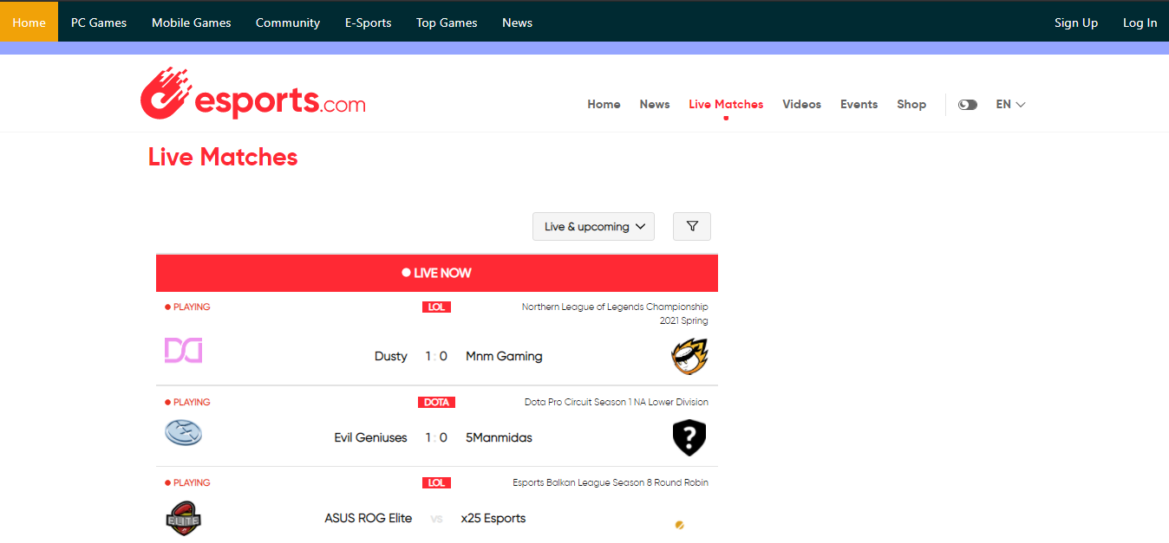

<body>

<center><embed src="https://www.esports.com/en/match-data” style="width:100%; height: 50vw;"></center>

</body>

Community:-

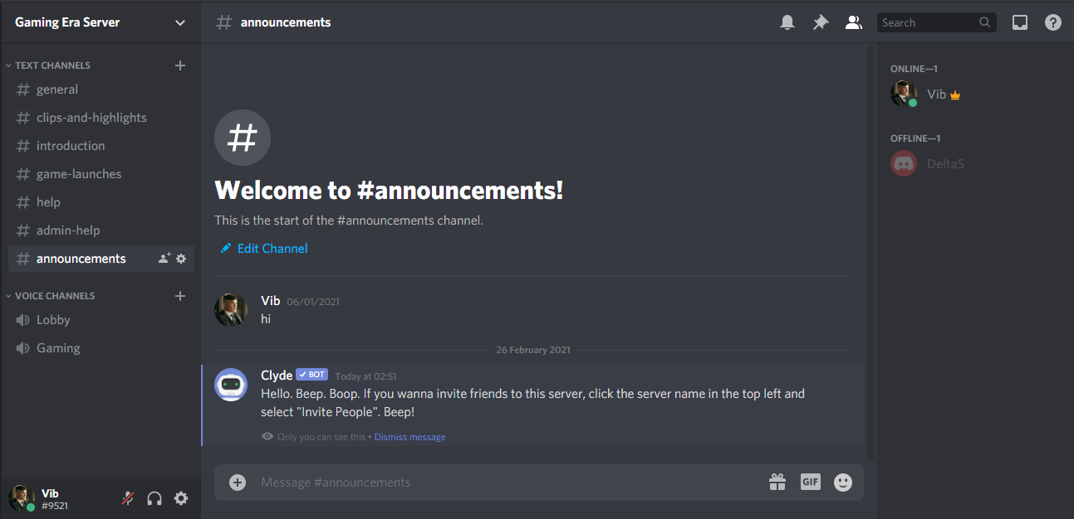

Here we have integrated Discord directly into the website.

Login:-

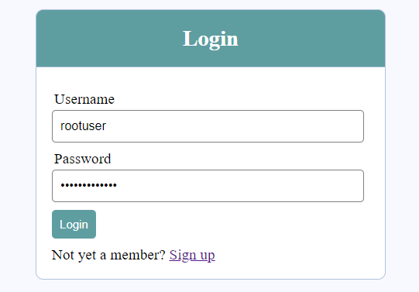

<?php include('server.php') ?>

<!DOCTYPE html>

<html>

<head>

<title>Login system</title>

<link rel="stylesheet" type="text/css" href="style.css">

</head>

<body>

<div class="header">

<h2>Login</h2>

</div>

<form method="post" action="login.php">

<?php include('errors.php'); ?>

<div class="input-group">

<label>Username</label>

<input type="text" name="username" >

</div>

<div class="input-group">

<label>Password</label>

<input type="password" name="password">

</div>

<div class="input-group">

<button type="submit" class="btn" name="login_user">Login</button>

</div>

<p>

Not yet a member? <a href="register.php">Sign up</a>

</p>

</form>

</body>

</html>

Sign Up:-

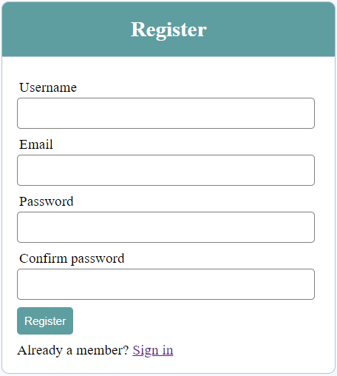

<?php include('server.php') ?>

<!DOCTYPE html>

<html>

<head>

<title>Registration system</title>

<link rel="stylesheet" type="text/css" href="style.css">

</head>

<body>

<div class="header"><h2>Register</h2>

</div>

<form method="post" action="register.php">

<?php include('errors.php'); ?>

<div class="input-group">

<label>Username</label>

<input type="text" name="username" value="<?php echo $username; ?>">

</div>

<div class="input-group">

<label>Email</label>

<input type="email" name="email" value="<?php echo $email; ?>">

</div>

<div class="input-group">

<label>Password</label>

<input type="password" name="password_1">

</div>

<div class="input-group">

<label>Confirm password</label>

<input type="password" name="password_2">

</div>

<div class="input-group">

<button type="submit" class="btn" name="reg_user">Register</button>

</div>

<p>Already a member? <a href="login.php">Sign in</a></p>

</form>

</body>

</html>

**Bibliography/References:**

The tentative list of the websites and secondary sources which shall be referred to for the purpose of this project are as under**:**

1. <https://www.w3schools.com/>
2. <https://www.geeksforgeeks.org/>
3. <https://gameplay.intel.com/>
4. <https://www.theverge.com/games>
5. <https://store.steampowered.com/>
6. <https://www.epicgames.com/store/en-US/>
7. <https://www.twitch.tv/>
8. <https://www.pcgamer.com/>

1. [https://newzoo.com/insights/articles/newzoo-games-market-numbers-revenues-and-audience-2020-2023/#:~:text=GamesThe%20World's%202.7%20Billion%20Gamers%20Will%20Spend%20%24159.3%20Billion%20on,Surpass%20%24200%20Billion%20by%202023&text=We%20forecast%20that%202020's%20global,year%20growth%20of%20%2B9.3%25](https://newzoo.com/insights/articles/newzoo-games-market-numbers-revenues-and-audience-2020-2023/#:~:text=Games-,The%20World's%202.7%20Billion%20Gamers%20Will%20Spend%20%24159.3%20Billion%20on,Surpass%20%24200%20Billion%20by%202023&text=We%20forecast%20that%202020's%20global,year%20growth%20of%20%2B9.3%25) accessed on November 1, 2020.
2. <https://edition.cnn.com/2018/08/27/us/esports-what-is-video-game-professional-league-madden-trnd/index.html> accessed on November 1, 2020.